Design Bus Timetable App by **Kuldeep Singh(1895270)**

Welcome to ‘**Travel with uS**’

‘Travel With Us’ is a bus booking app which is beneficial for two types of travellers **Intercity** and **Intracity**. User can easily book tickets and can also cancel them if needed.

1. Intercity Bus Booking : In this category user can use this app to travel within the city.
2. Intracity Bus Booking : In this category user can use this app to travel from one city to another.

Key Features :   
 a. Easy to use  
 b User Friendly design

c. Beneficial for Intercity travellers

d. Intracity travellers also can book ticket via this app  
 e. User can book ticket in 3 simple steps for intracity travelling  
 f. User can cancel ticket, download e-ticket  
 g. User can check full route of buses  
 h. User can select bus on the basis of Top Ratings, Price and Departure time  
 i. Option for user signup and create profile  
 j. Guest users can book ticket without sign up or login

k. User can cancel pre-booked tickets

l. Customer support 24/7

m. Secure payment method  
 n. User can easily check for buses from point A to B  
 o. Bus route will show every stop arrival/departure time

p. User can easily contact Our Customer support system

*NOTE : This APP design is divided in Four parts*

*1. Splash-Login-signup-Home Screens*

*2. Intercity Bus Booking*

*3. Intracity Bus Booking*

*4. Home screen SIDE DRAWER options.*

**1. Splash-Login-signup-Home Screens**

* Splash screen will open for 2-3sec, when user click ‘Travel with uS’ icon and after that moved to 2nd activity i.e Login/SignUp/Guest_User screen.
* Here user can signUp for new account or sign in or can also use app as a guest user.

**A 2**

**A 1**

Automatically move to login screen

After 2-3 seconds

If User Clicks

Guest User

**SPLASH ACTIVITY Login/SignUp/Guest_User ACTIVITY** 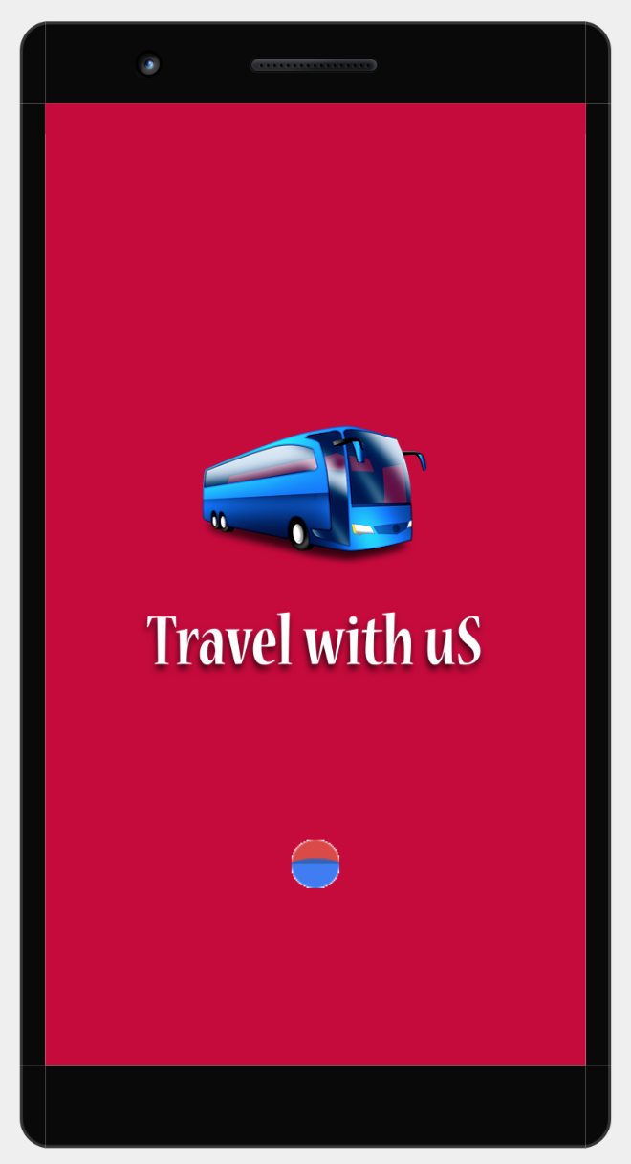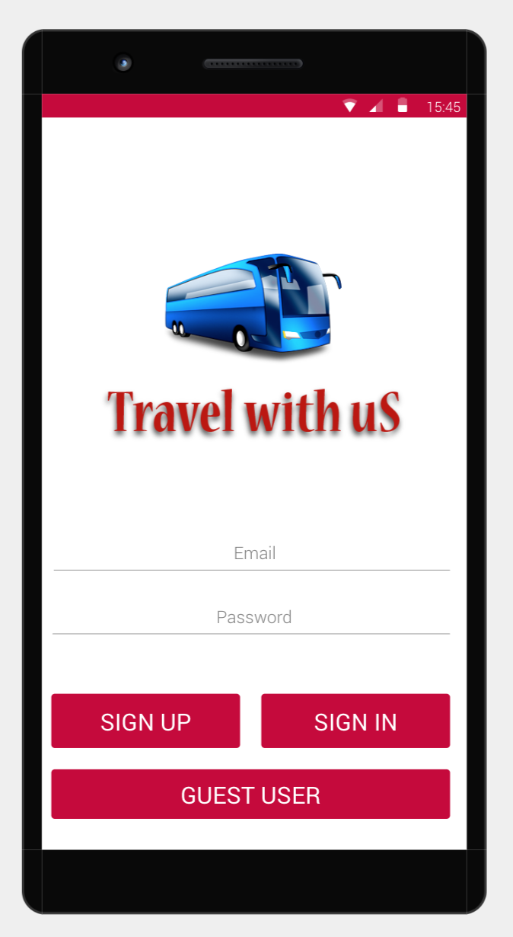





User enters login id and password

**SIGN UP ACTIVITY** 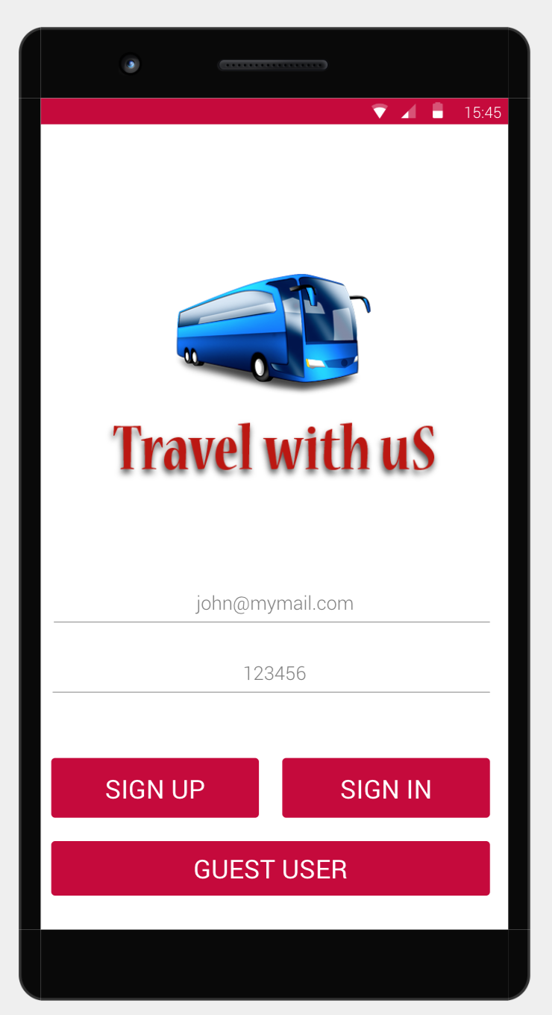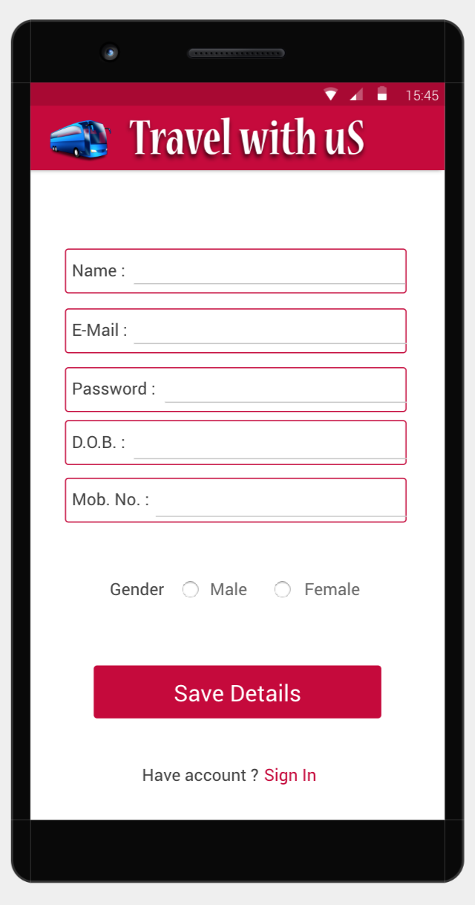

If User click TRY AGAIN

**A 5**

**A 4**

If User click SIGN UP

**A 3**

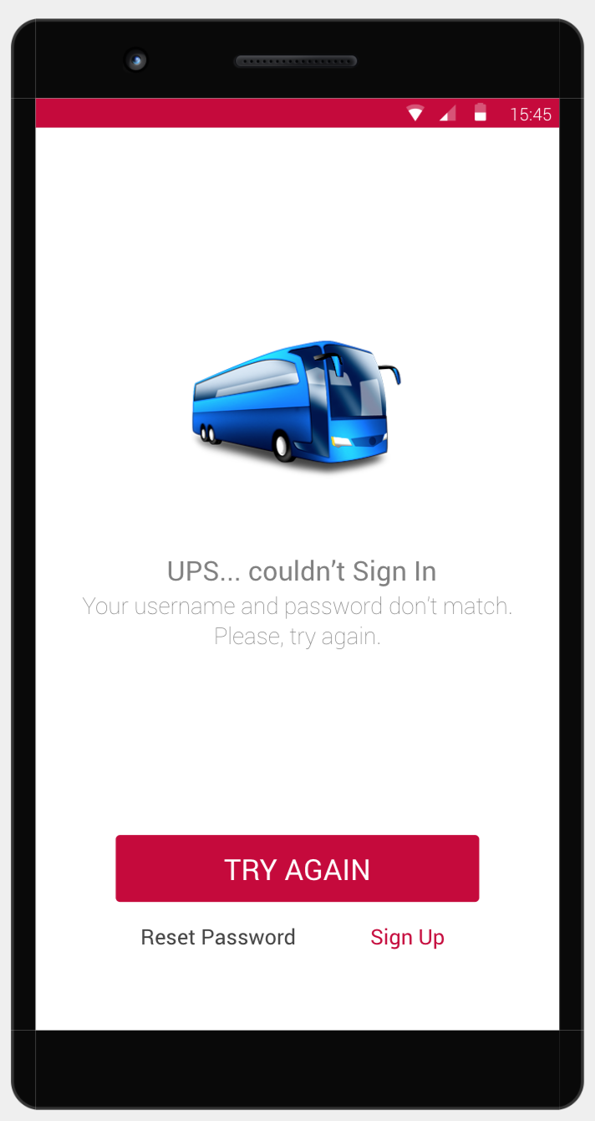

If User enter wrong

If User enter wrong

User enters

If User Click

Id and Password

Sign Up

If User Click

If id pass are correct

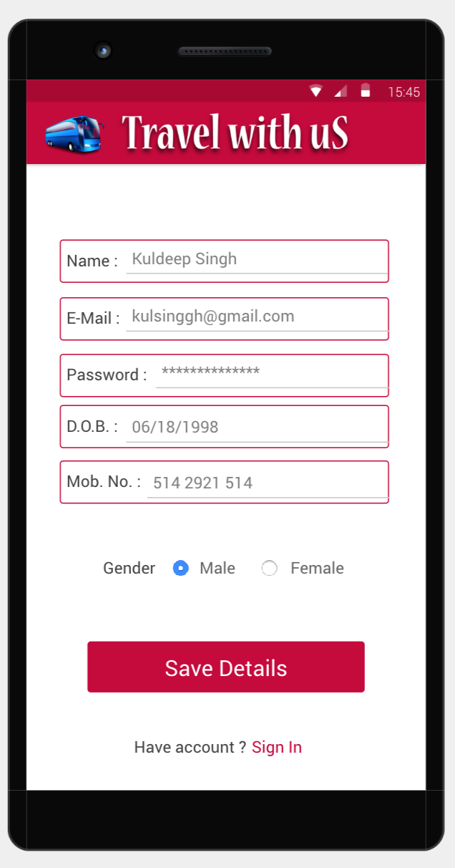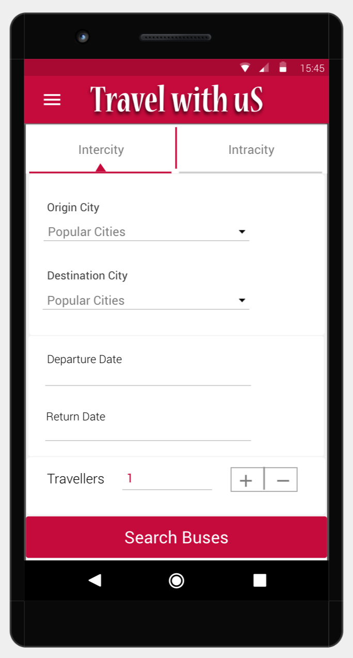

Save Details

If User Click

SIGN UP ACTIVITY

**SIGN UP ACTIVITY**

HOME SCREEN

User enters details

**HOME SCREEN**

**A 6**

**A 7**

If User Clicks Guest User button in A2

A2 = login/Signup/GuestUser Activity

**2. INTERCITY BUS BOOKING :** User can select two options in HOME SCREEN intercity and Intracity. First let’s see intercity bus booking. If user wants to travel from one city to other city.

**A 7**

**A 8**

**A 9**

**A 9**

Here User need to enter Origin City, Destination City, Departure Date, Return Date(only for two way journey) and no of travellers.

  
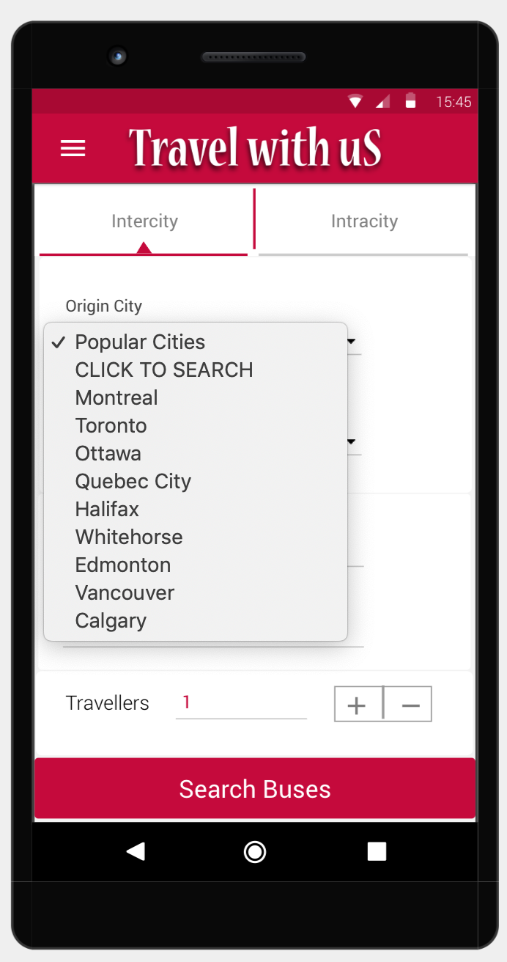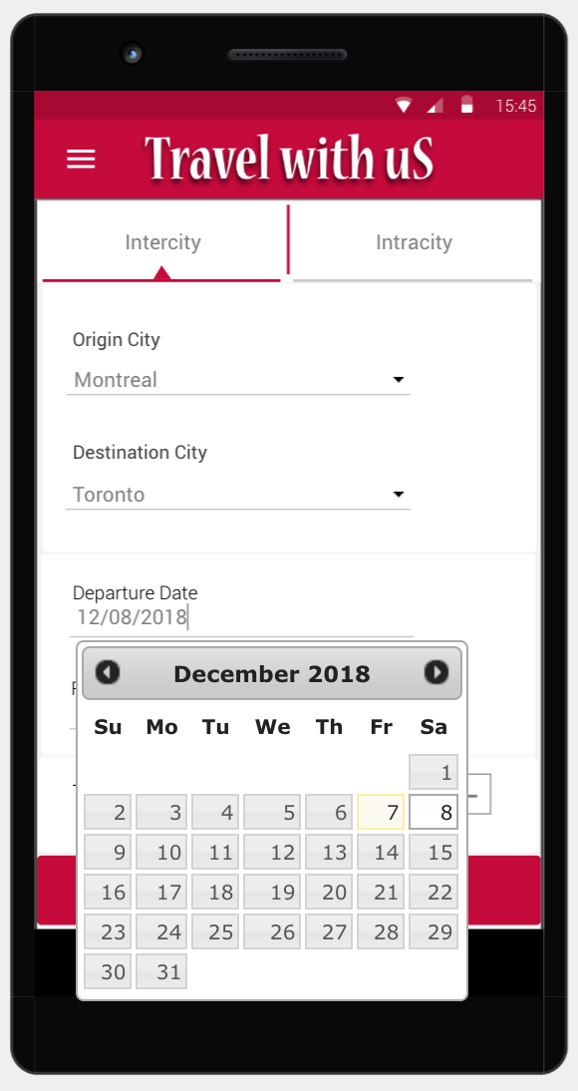

**HOME SCREEN**

Enter Cities

Enter Cities

User Click SEARCH BUSES

Enter Dates

Buses sorted Via Rating

**Buses sorted Via Rating**

**Buses sorted Via Price**

Loading Buses

**Loading Buses**

**BUS TimeTable Activity**

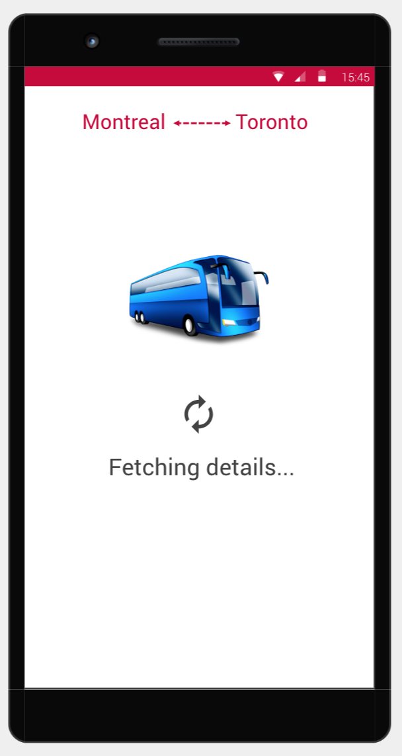

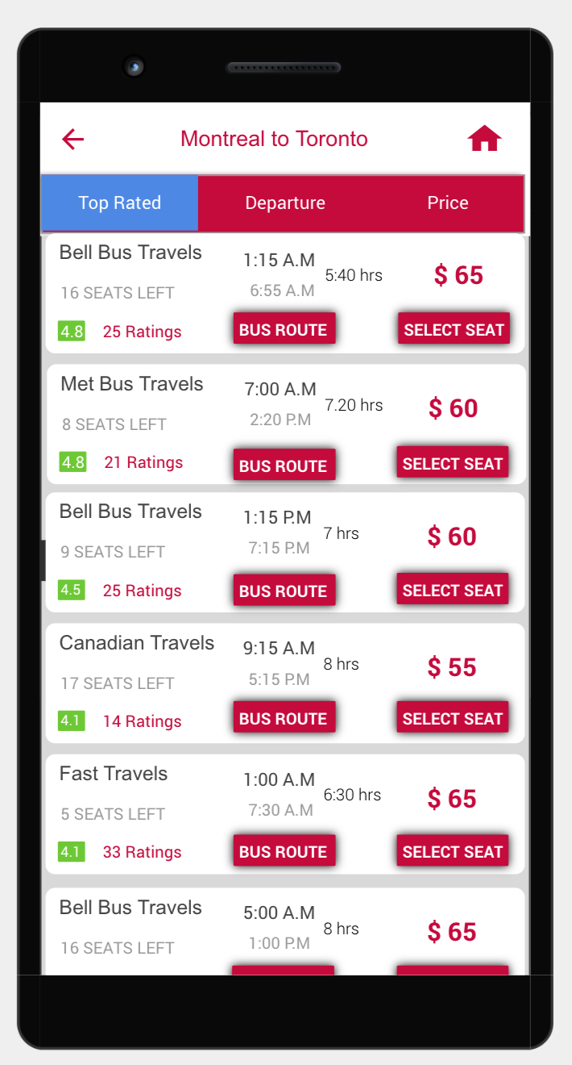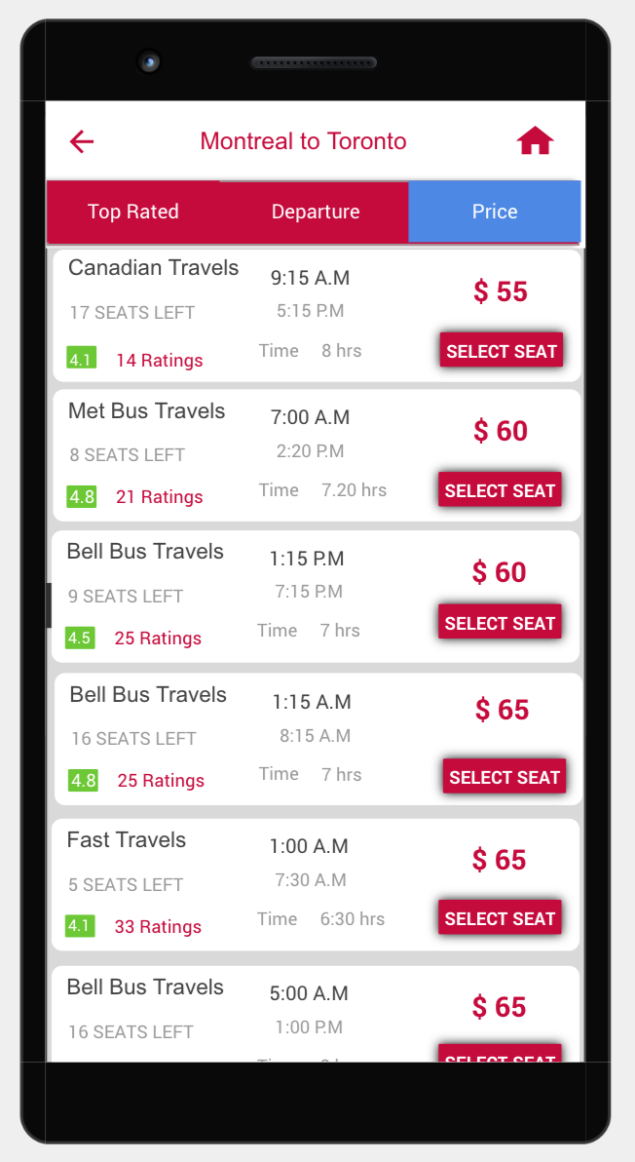

**A 7**

**A 12**

**A 11**

**A 10**

Enter Cities

User Clicks

User Clicks

Price Tab

User Selects Seat from

**Board/Drop Location Activity Activity**

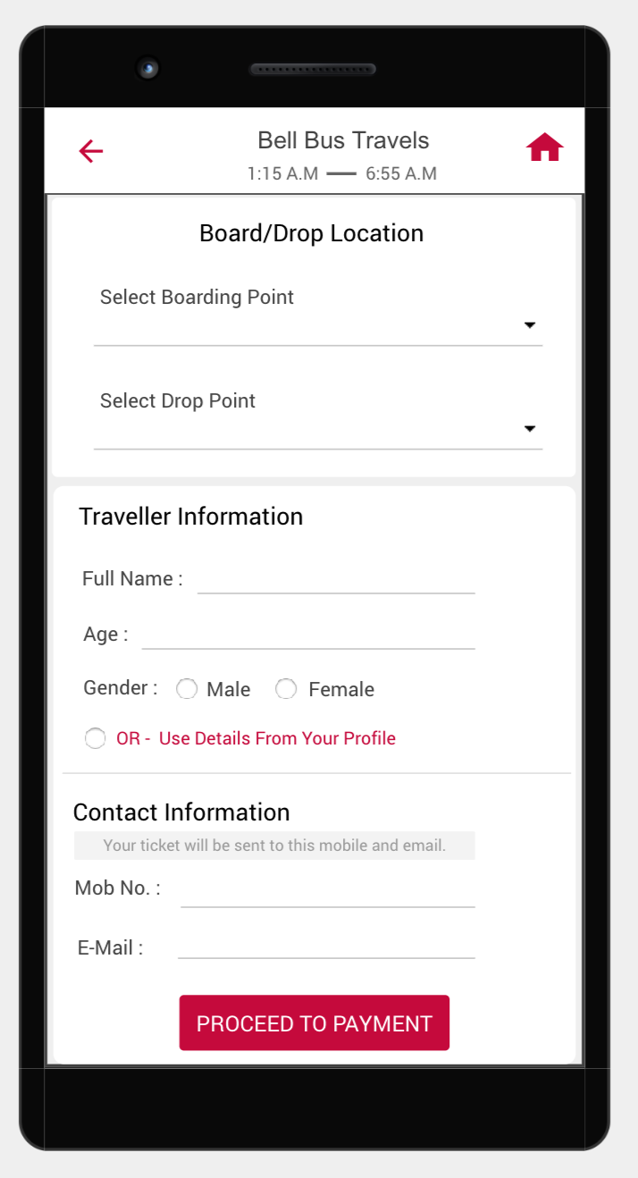  
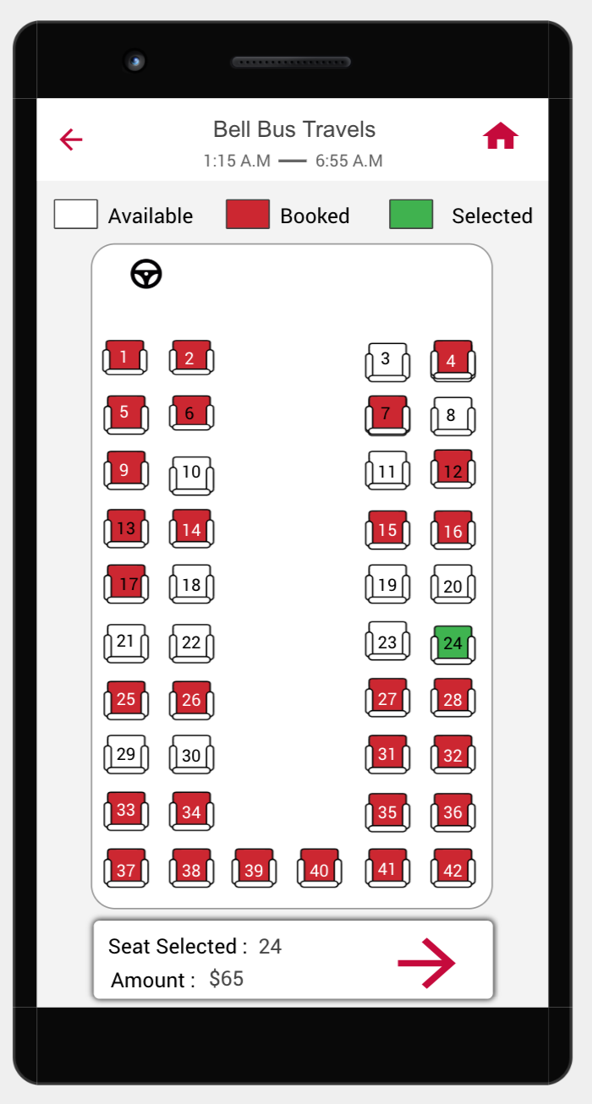

available seats

**Bus Seats Activity**

**A 7**

**A 13**

**A 14**

Enter Cities

User Clicks

User Click

Next

In this user needs to select

In this user needs to select

Boarding and Drop Location

And Traveller Information

Next

Buses sorted Via Rating

Buses sorted Via Rating

**PAYMENT PAGE**

User can easily check Bus Route, download ticket and cancel tickets in My Booking Activity.

**SEAT CONFIRMED**

**MY BOOKINGS ACTIVITY**

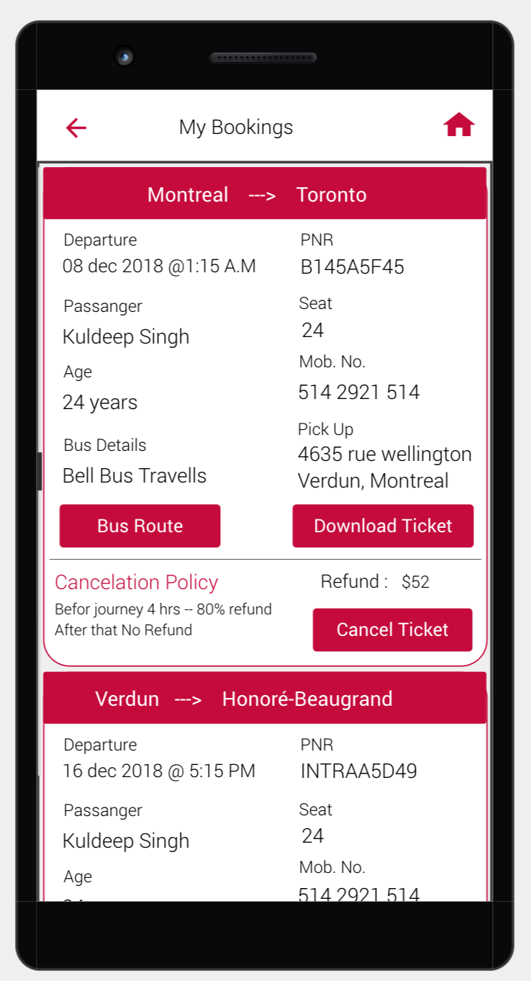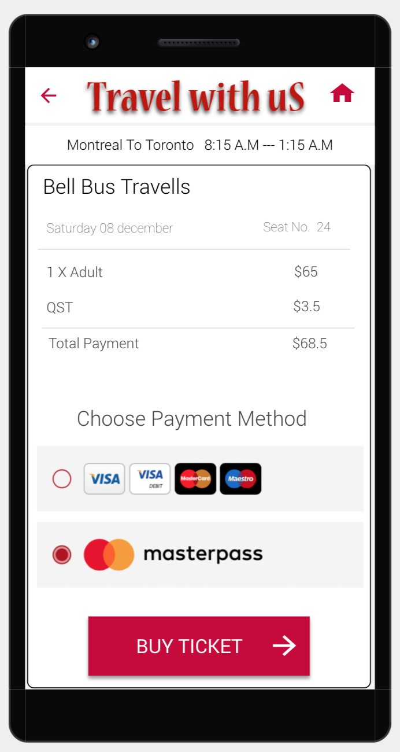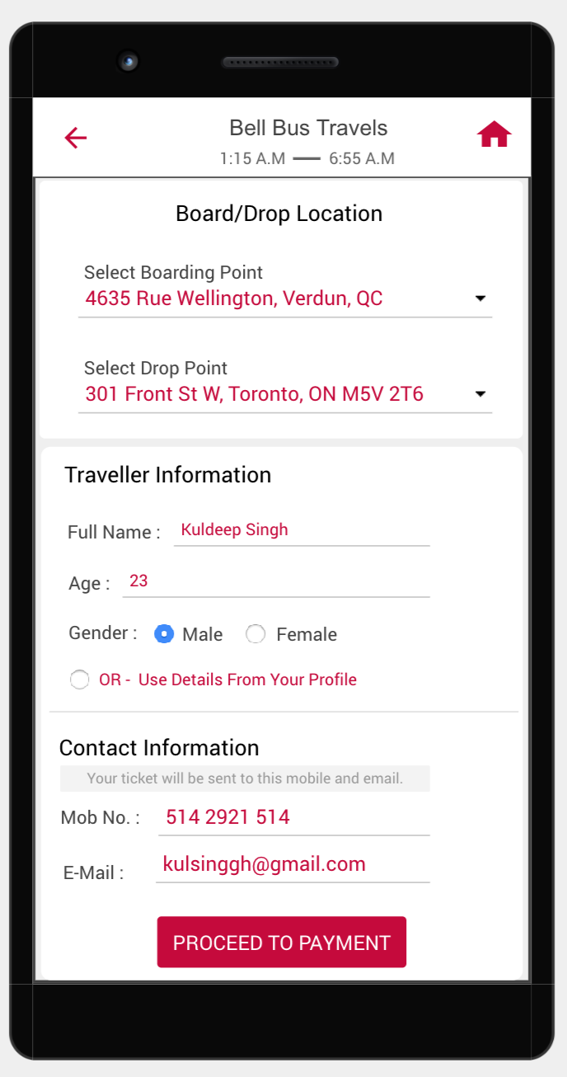

**A 7**

**A 12**

**A 12**

**A 15**

**A 16**

**A 17**

Enter Cities

User Clicks

Buy Ticket

User Click

User Click

Proceed to Payment

User Click

**SEAT CONFIRMED**

**3. INTRACITY BUS BOOKING :** If user wants to travel within the city than user needs to select intracity option in home screen.

**A 7**

**A 8**

**A 9**

Here user need to enter Pickup Location, Drop Location, Departure Date, no of travellers and Travellers Information.

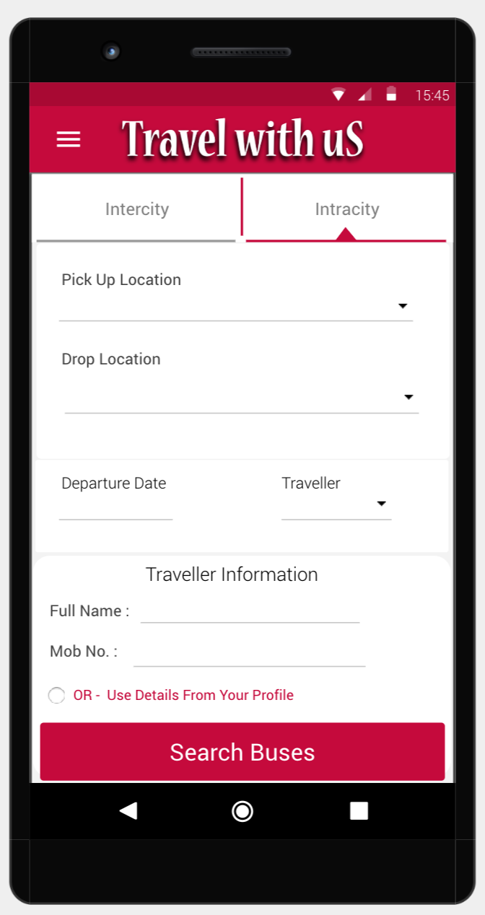  
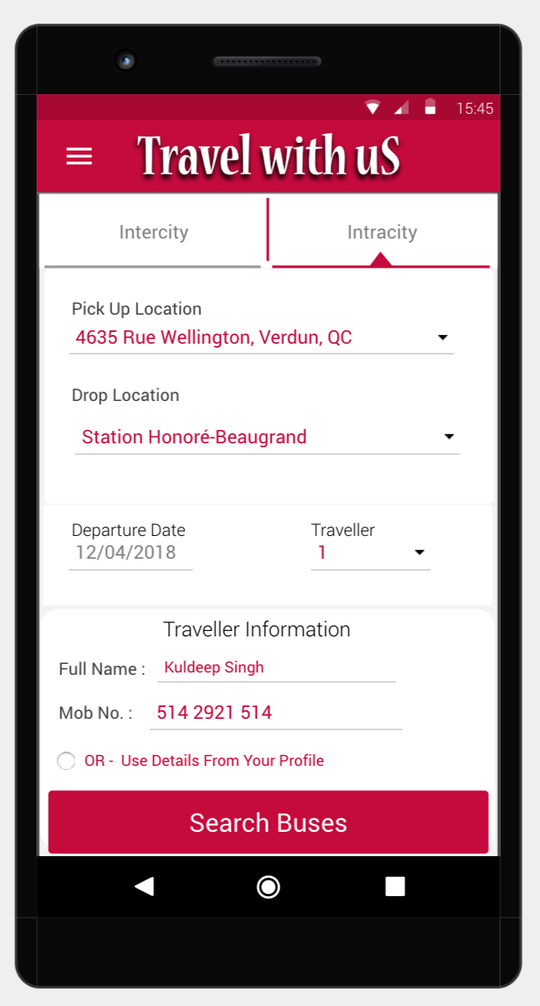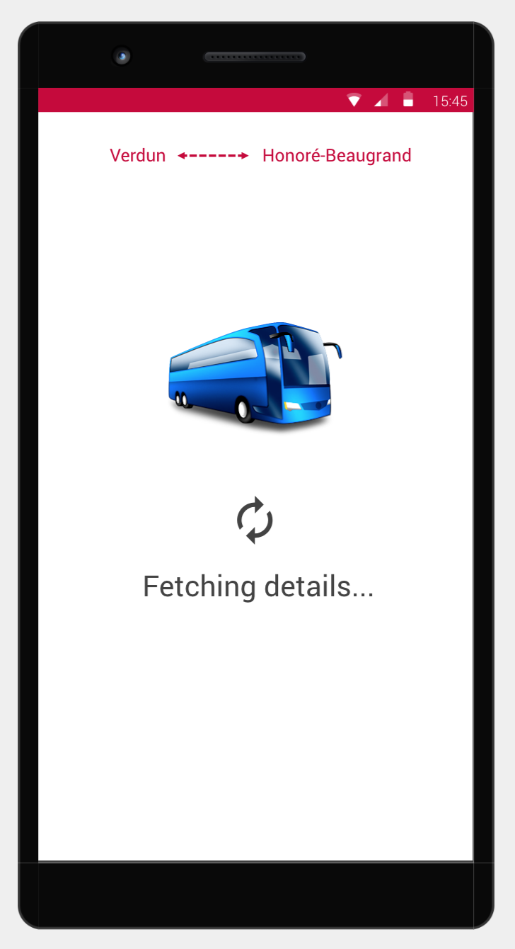

**HOME SCREEN**

Enter Cities

Enter Details

User Click

Search Buses

**SELECT BUS ACTIVITY**

**BUS ROUTE ACTIVITY**

**BUS ROUTE ACTIVITY**

**SELECT SEAT ACTIVITY**

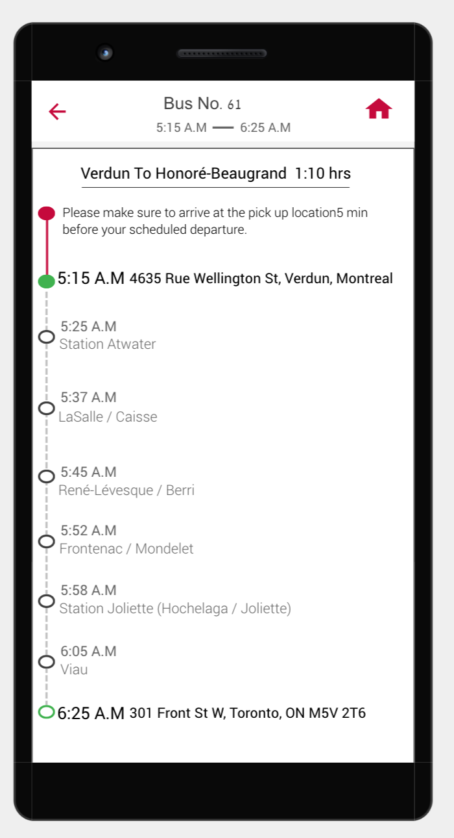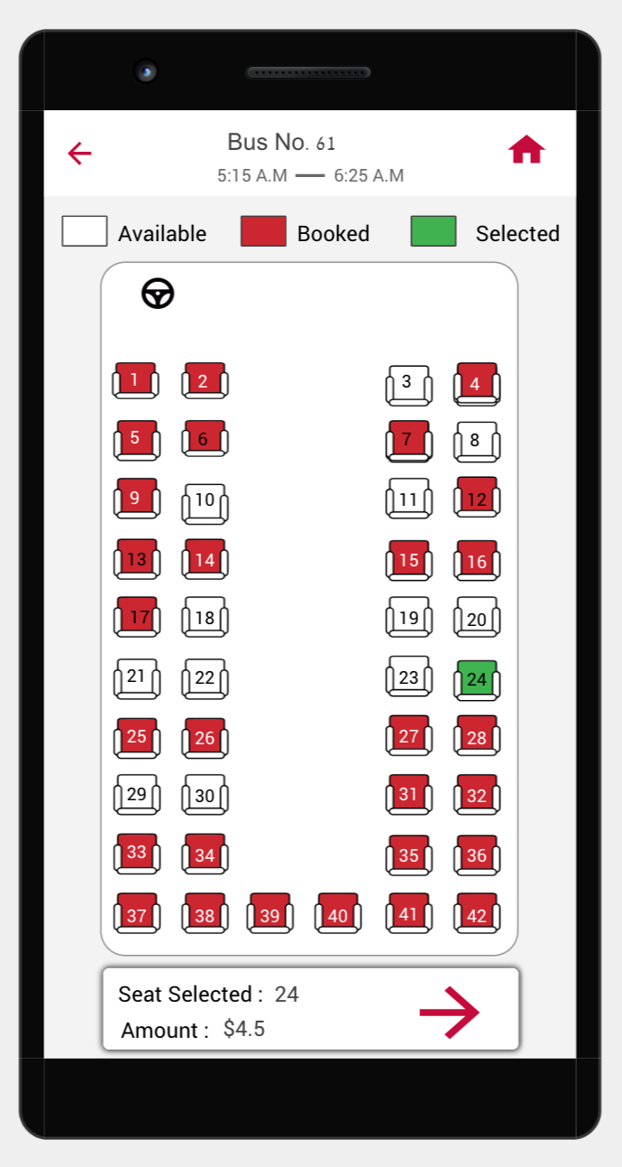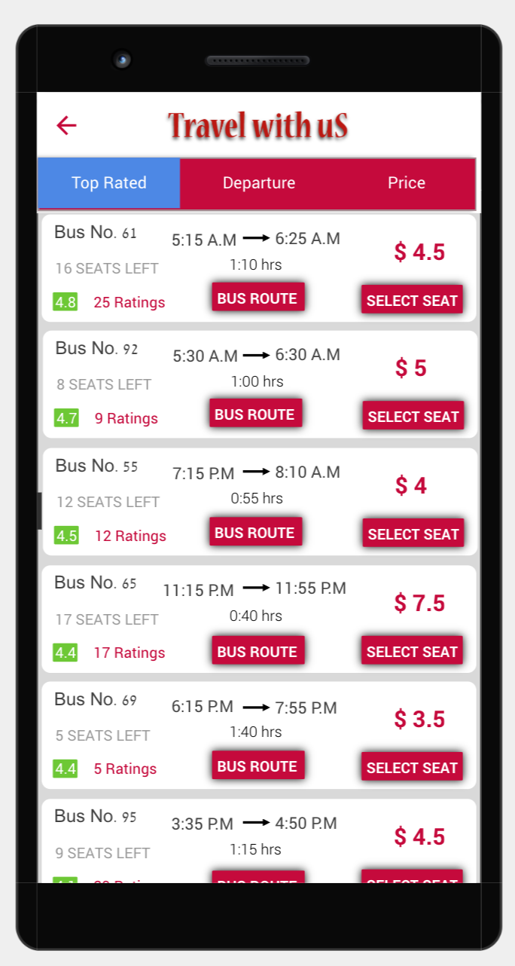

available seats

**A 14**

Next

User Click

BUS ROUTE

User Click

SELECT SEAT

**SEAT CONFIRMED**

**SEAT CONFIRMED**

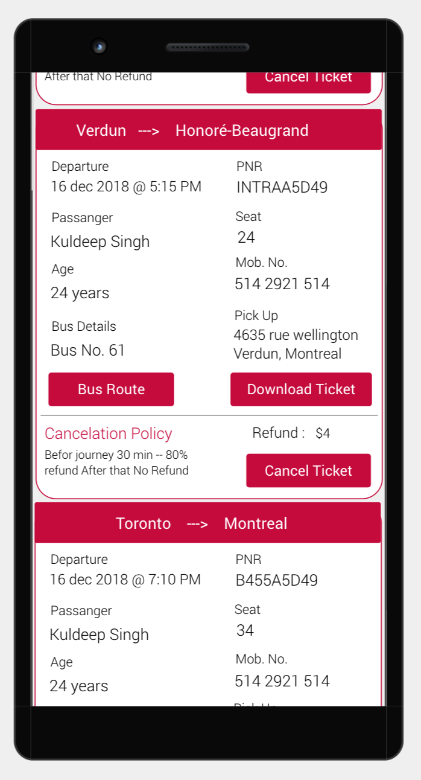  
  
  
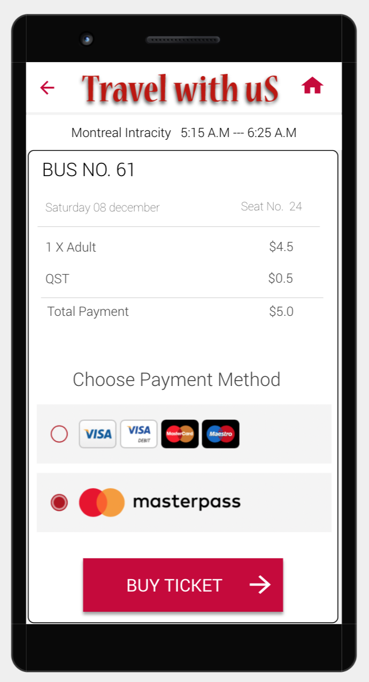

**PAYMENT ACTIVITY**

**A 12**

**A 12**

**A 15**

**A 16**

User Click

Buy Ticket





**4. SIDE DRAWER :**

There is a side drawer button in the Left Top corner in HOME SCREEN, if user clicks that button a side drawer or screen will comes out from the left side on the same screen(Home screen). This side drawer consists of USER PROFILE, HOME, MY BOOKINGS, CONTACT US and SIGN OUT options.

**User Profile** : It consists of the details about user which are entered while signing up.

**A 12**

**A 12**

**A 15**

**My Bookings** : It consists of all booking current or past that user had booked either Intracity or Intercity.

**Contacts Us :** This page consists of all details like address, mobile number, email address, etc about ‘Travel with uS’ company.

**Sign Out :** User can signet from the currently signed account by clicking this option.

**User Profile Activity**

**CONTACT US Activity**

**SIDE DRAWER**

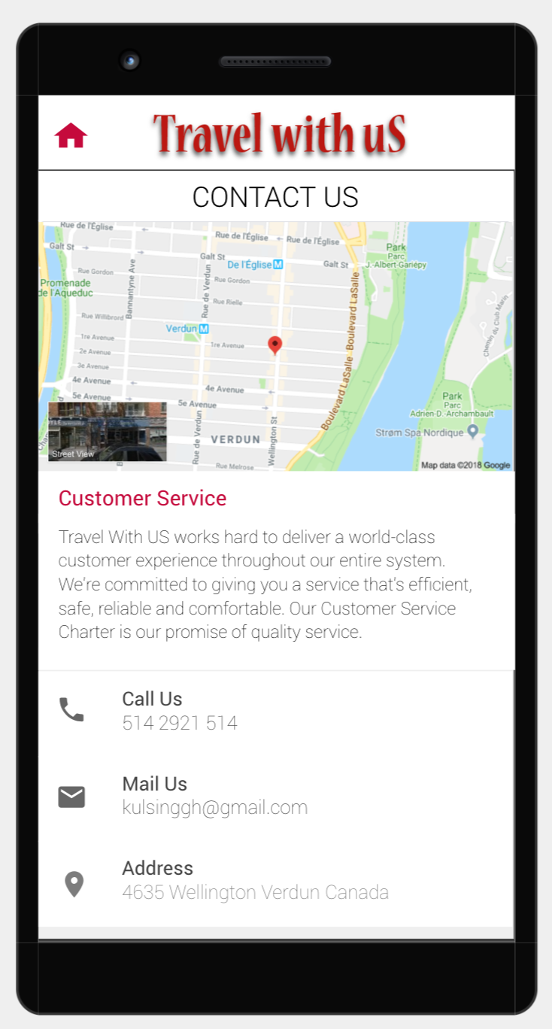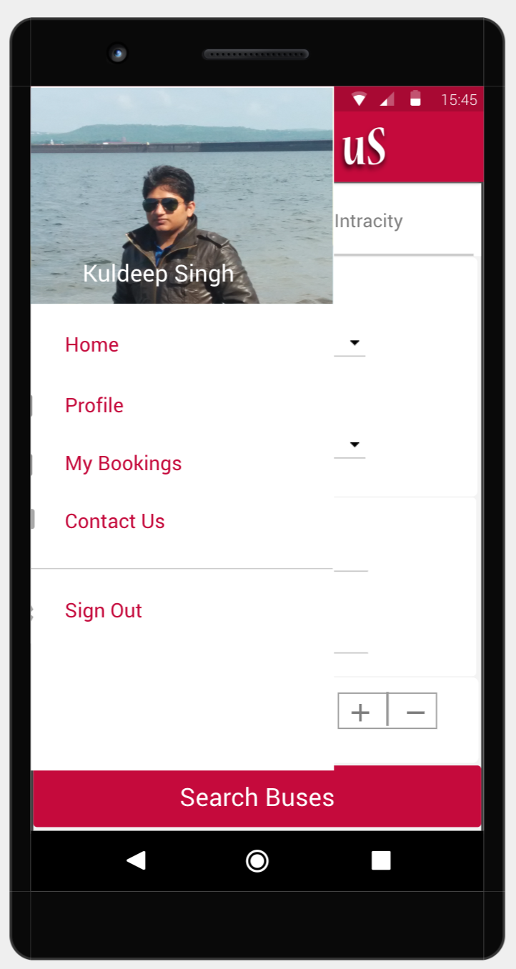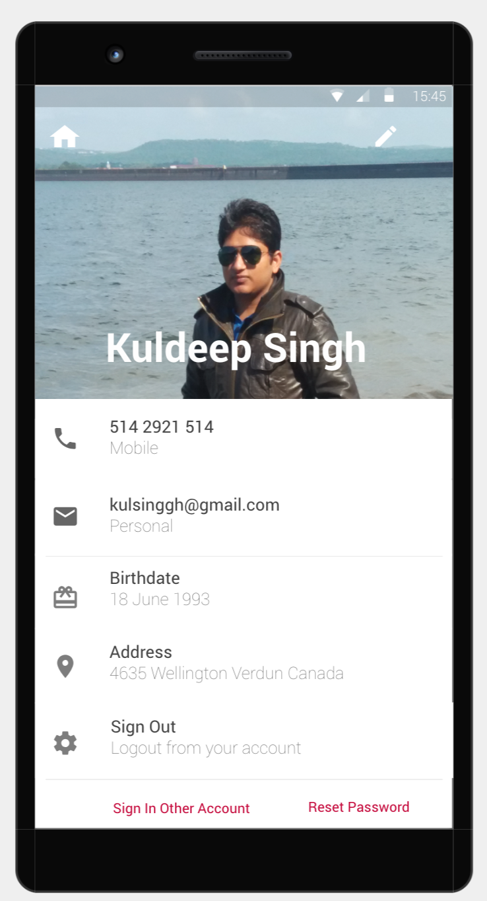

**A 12**

**A 12**

**A 15**

**Montreal To Toronto Route**

**BUS ROUTE ACTIVITY**

**MY BOOKINGS ACTIVITY**

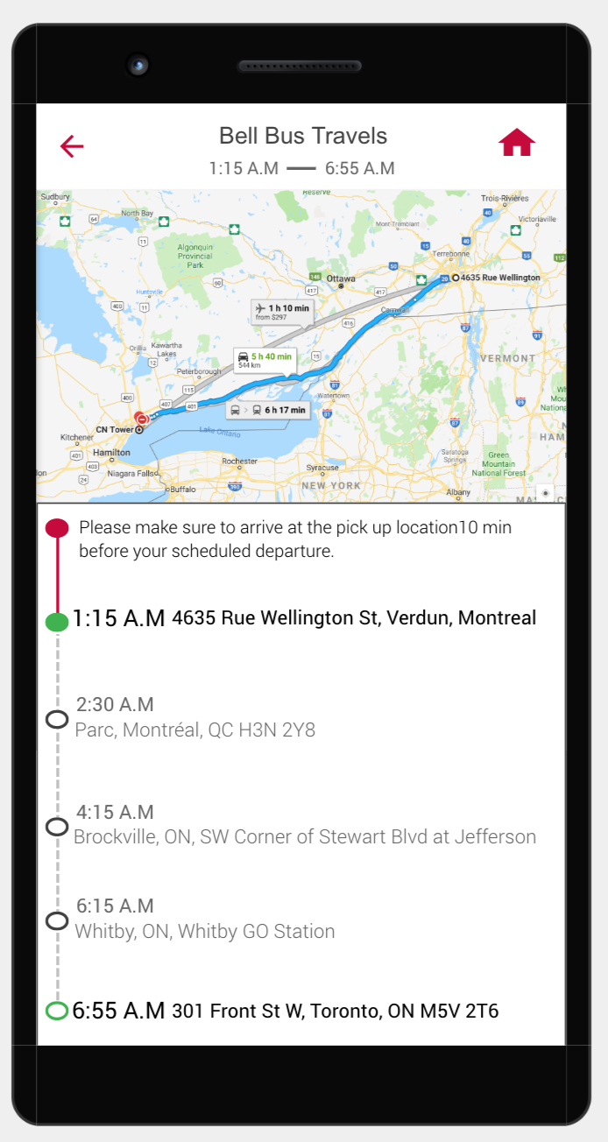  


In this screen user can see his/her current

bus booking tickets and previous tickets

he/she had booked. This screen will show

bookings for both intercity and intracity

travels.

Extra Features :

User can easily download the e-ticket by  
clicking on **Download Ticket** button  
  
User can see the bus route for selected

**A 12**

**A 12**

**A 15**

bus ticket bus by clicking **Bus Route**button.

User can easily cancel the ticket by

clicking on **Cancel Ticket** button.